1. Which of the following regular expression resembles the given diagram?  
[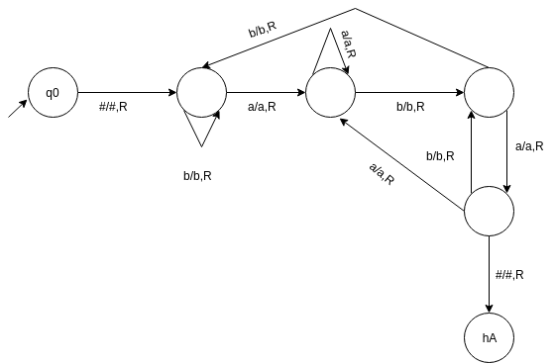](https://www.sanfoundry.com/wp-content/uploads/2017/05/automata-theory-questions-answers-turing-machine-halting-q1.png)  
a) {a}*{b}*{a,b}

b) {a,b}*{aba}

c) {a,b}*{bab}

d) {a,b}*{a}*{b}*

2. Construct a turing machine which accepts a string with ‘aba’ as its substring.  
[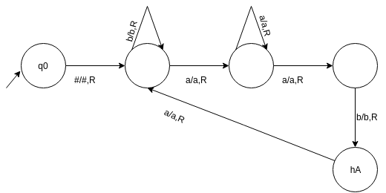](https://www.sanfoundry.com/wp-content/uploads/2017/05/automata-theory-questions-answers-turing-machine-halting-q2a.png)

a)  
[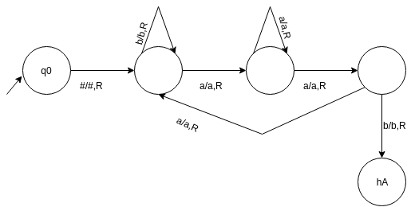](https://www.sanfoundry.com/wp-content/uploads/2017/05/automata-theory-questions-answers-turing-machine-halting-q2b.png)

b)

C)[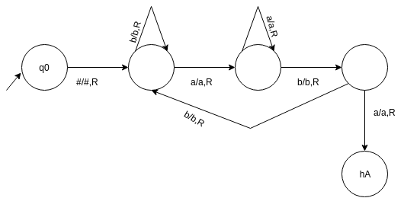](https://www.sanfoundry.com/wp-content/uploads/2017/05/automata-theory-questions-answers-turing-machine-halting-q2c.png)  
[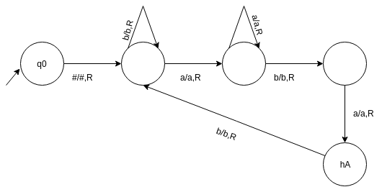](https://www.sanfoundry.com/wp-content/uploads/2017/05/automata-theory-questions-answers-turing-machine-halting-q2d.png)

d)

3. The number of states required to automate the last question i.e. {a,b}*{aba}{a,b}* using finite automata:

a) 4

b) 3

c) 5

d) 6

4. The machine accept the string by entering into hA or it can:

a) explicitly reject x by entering into hR

b) enter into an infinte loop

c)Both (a) and (b)

d) None of the mentioned

5.d(q,X)=(r,Y,D) where D cannot be:

[automata-theory-questions-answers-turing-machine-halting-q5](https://www.sanfoundry.com/wp-content/uploads/2017/05/automata-theory-questions-answers-turing-machine-halting-q5.png)  
a) L

b) R

c) S

d) None of the mentioned

6. Which of the following can accept even palindrome over {a,b}

a) Push down Automata

b) Turing machine

c) NDFA

d) All of the mentioned

7. Which of the functions can a turing machine not perform?

a) Copying a string

b) Deleting a symbol

c) Accepting a pal

d) Inserting a symbol

8. If T1 and T2 are two turing machines. The composite can be represented using the expression:

a) T1T2

b) T1 U T2

c) T1 X T2

d) None of the mentioned

9. The following turing machine acts like:

[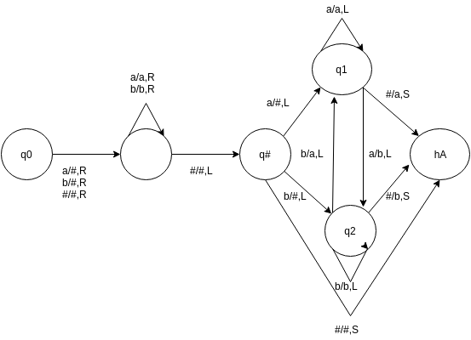](https://www.sanfoundry.com/wp-content/uploads/2017/05/automata-theory-questions-answers-turing-machine-halting-q9.png)  
a) Copies a string

b) Delete a symbol

c) Insert a symbol

d) None of the mentioned

10. What does the following transition graph shows:

[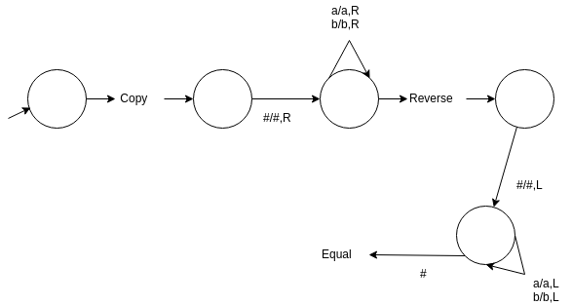](https://www.sanfoundry.com/wp-content/uploads/2017/05/automata-theory-questions-answers-turing-machine-halting-q10.png)  
a) Copies a symbol

b) Reverses a string

c) Accepts a pal

d) None of the mentioned